**Cdd_J6 New Tx Signal Add**

**User Guide**

# Introduction

The precoditions are that the new system extract has been imported in DaVinci Configurator and new signal_table.h upon the new system extract has been generated.

Take GB System Extract 140 as example.

According to the diff report diff_analysis_140signals.xlsx, a new frame "CSM_RadioLow_CAN5_MSG04" added in the database, including two signals "OATDispdVal" and "OATDispdVal_DuD".

# Scope

This document show how to add CddJ6_TxSignal in Vector Davinci Developer & Configurator.

# Contents

1. Introduction 2

2. Scope 2

3. Contents 2

4. Detail Procedure to make CDDJ6_Tx Signal 3

4.1 Check Application Port in CSMEcuComp 3

4.2 Change port prototype name as naming convention 4

4.3 Verify data element of port prototype 5

4.4 Connect Port from CSMEcuComp to Cdd_J6 5

4.5 Check P-Port in “Cdd_J6” and add port access in ‘Runnable_J6Rx” 7

4.6 Sync with Davinci Configurator & Generate Code 7

4.7 Modify “J6_prv_Can.c” 8

5. ETC 10

6. Revision History 11

Appendix A 12

A-1. When Port already exist in Step 4.4. Connect Port from CSMEcuComp to Cdd_j6 12

# Detail Procedure to make CDDJ6_Tx Signal

## Check Application Port in CSMEcuComp

Open Vector DaVinci Developer project and then navigate to SWC Composition "CSMEcuComp". Check there are "OATDispdVal" and "OATDispdVal_DuD" port prototype as Application port.

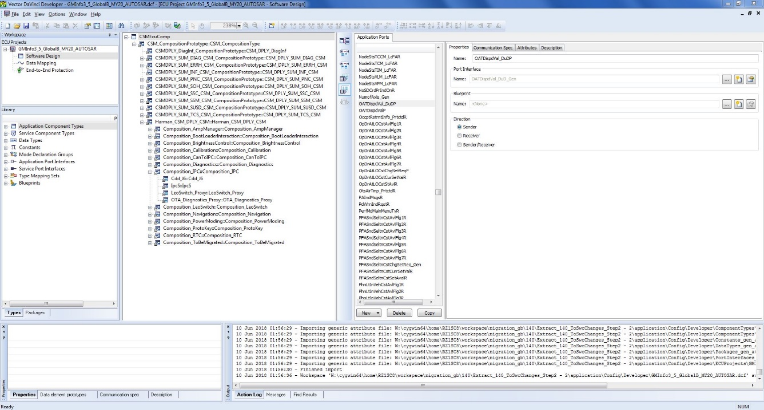

If there is no "OATDispdVal" and "OATDispdVal_DuD"port, generate port prototype in ‘Signal view mode’ in Data Mapping



Create Port Prototype as default option



## Change port prototype name as naming convention

Change signal name OATDispdVal_DuDP to OATDispdVal_DuD_Gen to follow the same name pattern as Harman did. Take the same action for signal name OATDispdValP



## Verify data element of port prototype

Verify the data element attached to the port prototype is configured properly, including init value, data type, etc. Please go through Tab "Communication Spec". Check Data Type is proper in Interface Properties tab.



## Connect Port from CSMEcuComp to Cdd_J6

Go to "CSMEcuComp". Find P-port prototype OATDispdVal_DuD_Gen in Connector Prototype List (**R-port View**) and create a connector to Harman Composition prototype "CSM_CompositionPrototype" by right click on the broken connector and select "Complete Ports". In poped up window, select "Software Component Ports" and browse in an Objects list and select

|  |
| --- |
|  |

|  |
| --- |
|  |

Go down to "CSM_CompositionPrototype". Find P-port prototype OATDispdVal_DuD_Gen in Connector Prototype List (R-port View) and create a connector to Harman Composition prototype "Harman_CSM_DPLY_CSM" by right click on the broken connector and select "Complete Ports". In poped up window, select "Software Component Ports" and browse in an Objects list and select

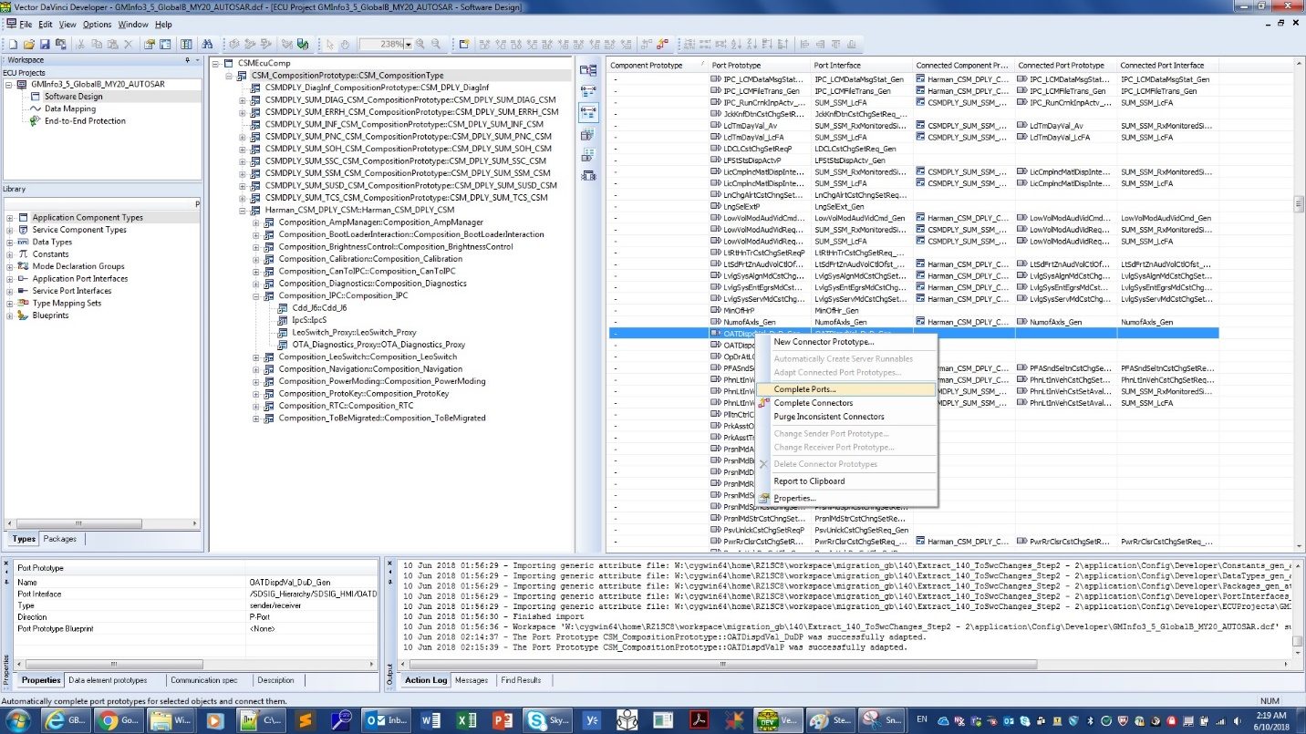

Do the same ‘Complete Ports’ process in Harman_CSM_DPLY and Composition_IPC.

## Check P-Port in “Cdd_J6” and add port access in ‘Runnable_J6Rx”

Go down to SWC "Cdd_J6". Check if P-ports OATDispdVal_DuD_Gen and OATDispdVal_Gen is existing and the configuration is correct. Then, switch to pane "**Runnable Entity List**" and add port access to OATDispdVal_Gen in runnable "**Runnable_J6Rx**" (select New -> Write Data (non-queued) at the bottom of the window)

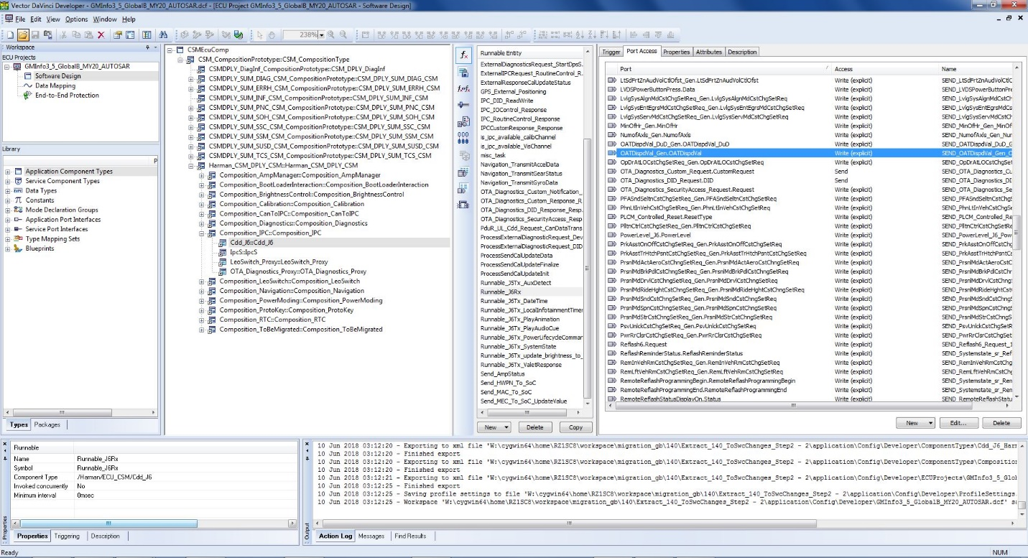

## Sync with Davinci Configurator & Generate Code

Go back to DaVinci Configurator. **Generate code(RTE)** and **SWC Cdd_J6 (Cdd_J6.c)**. After generation done, open source file" Cdd_J6.c" and locate the two RTE interfaces generated "Rte_Write_OATDispdVal_Gen_OATDispdVal" and "Rte_Write_OATDispdVal_DuD_Gen_OATDispdVal_DuD". Additionally, you can find the definition and implementation in "Rte_SystemApplication_OsCore_CORE0.c".

Figure 1 Code Snippet in Cdd_J6.c

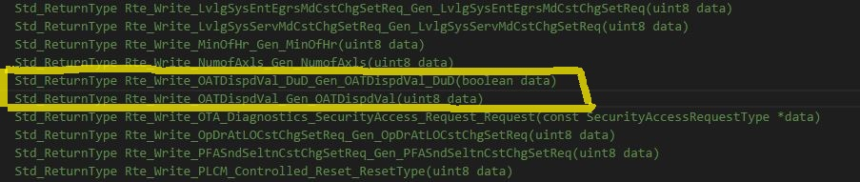

Figure 2 Code Snippet in Rte_SystemApplication_OsCore_CORE0.c

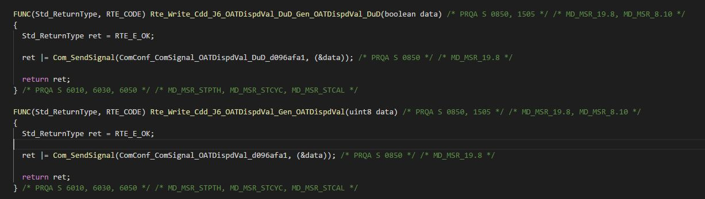

## Modify “J6_prv_Can.c”

Open source file "J6_prv_Can.c" (Source\CDD_J6\J6_prv_Can.c). Add the code in function "VIS_Tx_CAN_Signal_VIS_Tx_CAN_Signal" to call the RTE interfaces to send signals "OATDispdVal_Gen" and "OATDispdVal_DuD_Gen" to Can bus. See code snippet below.

Figure 3 Code Snippet in J6_prv_Can.c

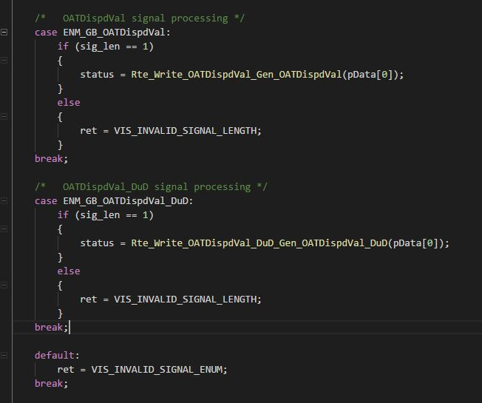

If it's group signal, it should be processed in one case as part of signal group as well as a seperate case for the signal, but only one RTE interface for the signal group is generated and called in group signals process.

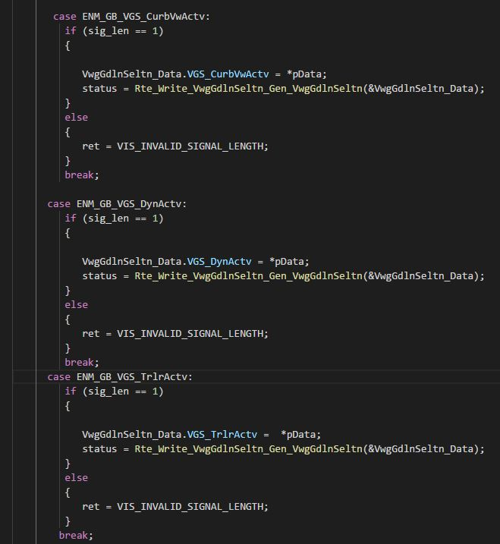 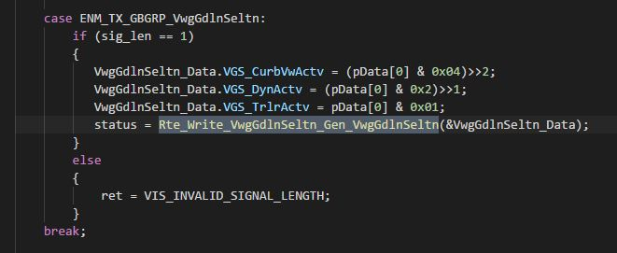

# ETC

# Revision History

| **Date** | **Version** | **Author** | **Description** |
| --- | --- | --- | --- |
| 6/15/2018 | 0.1 | Yong Yin | Initial version Release CddJ6_TxSignal_Add_UserGuide.xlsx |
| 8/28/2019 | 0.2 | Chinkyu Kang | Modify to docx format . |
|  |  |  |  |
|  |  |  |  |

# Appendix A

## A-1. When Port already exist in Step 4.4. Connect Port from CSMEcuComp to Cdd_j6

Switch to Connector Prototype List (R-port view) and update the connected port prototype "OATDispdVal_DuDP" and interface by right click on the connector and select "Adapt Connected Port Prototypes". In the window poped up, check "Name", "Init Value" and "Attributes", then click "OK". Take the same action for connected port prototype "OATDispdValP"

